Wang Zhang

CSC 560  Dr.lee

Lab 2 report

**Display weather android application**

This a weather display app for android system. 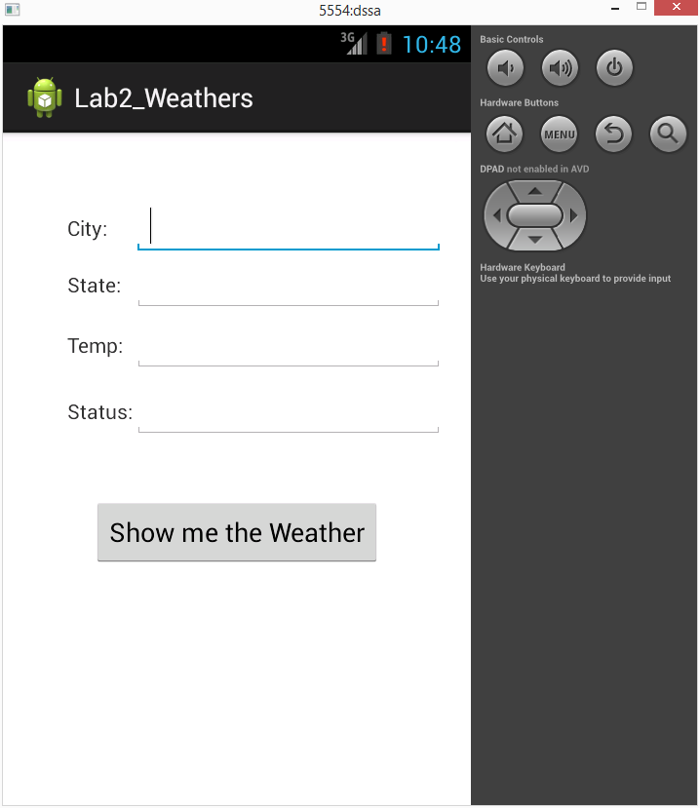

This is the initial screen for this app. As we can see it basically display the city, state, temperature and status.

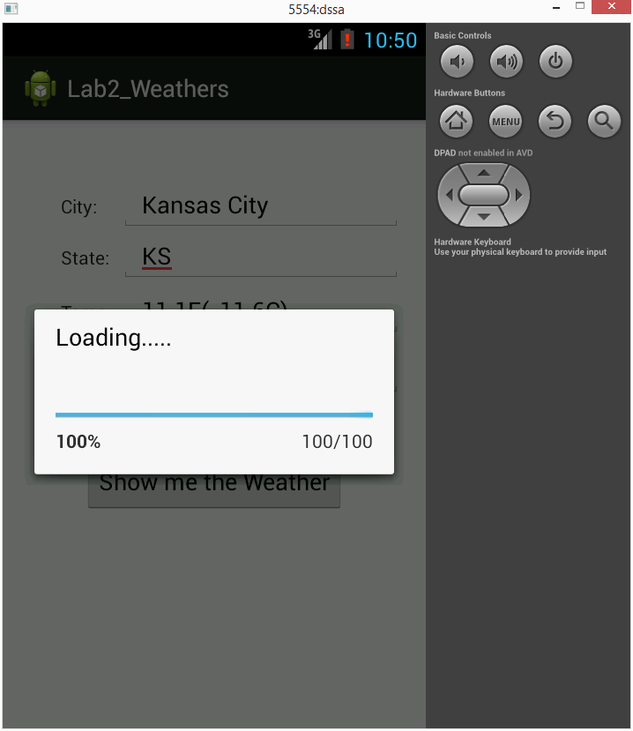

This is the loading screen. I added a progress bar to show the progress while the weather info is loading.

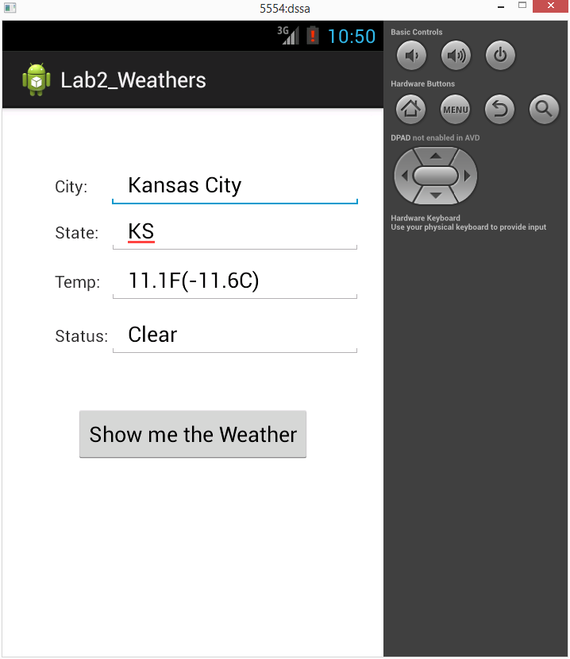

After loading, the city and its temperature status will display on text fields.